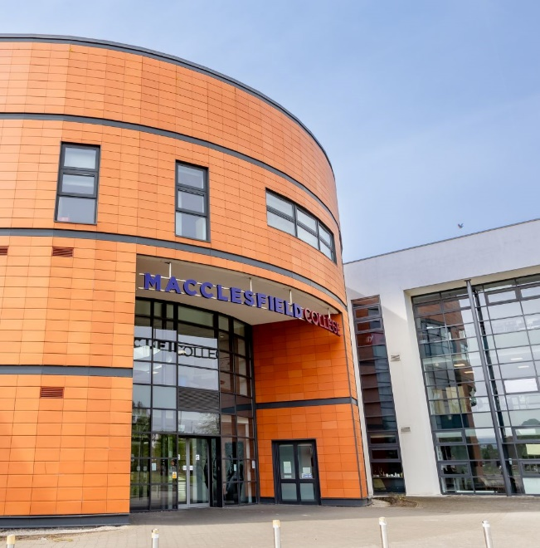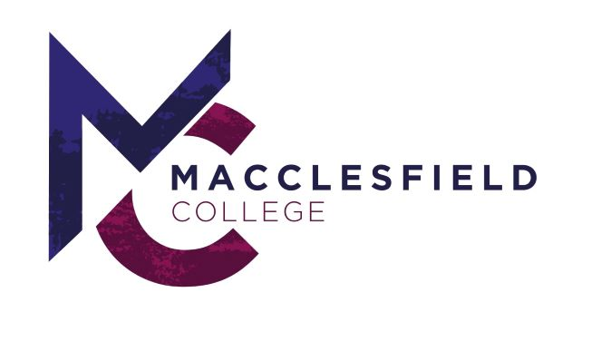



MACCLESFIELD COLLEGE

**GENDER PAY REPORT 2024**

**(Published March 2025)**

# **CONTENTS**

|  |  |  |  |
| --- | --- | --- | --- |
| **1. Introduction** | **Pg 3** | **9. Horizontal Segregation** | **Pg 6** |
| **2. Gender Pay Definition of an ‘Employee’** | **Pg 3** | * 1. Business Support   2. Academic Staff |  |
|  |  | **10. Vertical Segregation** | **Pg 6** |
| **3. The Gender Pay Gap** | **Pg 3** |  |  |
|  |  | **11. Employee relations** | **Pg 7** |
| **4. Macclesfield College Headline Gender Pay Data** | **Pg 3** |  |  |
| * 1. Mean Gender Pay Gap   2. Median Gender Pay Gap |  | **12. Promoting & Advancing Gender Diversity** | **Pg 7** |
| **5. National Gender Pay comparator** | **Pg 4** | * 1. Recruitment   2. Family Friendly   3. Continuous Professional Development/Training & Development |  |
| **6. Bonus Gender Pay** | **Pg 4** |  |  |
|  |  | **13. Closing Statement** | **Pg 8** |
| **7. Quartile Pay Bands** | **Pg 4** |  |  |
| * Gender |  |  |  |
| **8. Why Macclesfield College has a ‘Gender Pay Gap’** | **Pg 5** |  |  |
| * Occupational Segregation |  |  |  |

1. **Introduction**

Macclesfield College is delighted to publish this Gender Pay Gap Report in accordance with Section 78 of the Equality Act 2010 (Gender Pay Gap Information) Regulations.

The Report is based on the ‘snapshot’ date for public authorities of 31 March 2024. Further information about the Gender Pay Regulations may be sourced at:

[www.gov.uk/government/news/gender-pay-gap-reporting](http://www.gov.uk/government/news/gender-pay-gap-reporting)

With a ‘headcount’ of 234 on the ‘snapshot date’ the profile of Macclesfield College’s staff population was 35% males and 65% female.

This silhouette aligns with the wider education sector gender ratios of staff employed, namely over 64 % are female and over 36% male.

The Gender pay gap shows the difference in the average earnings between all men

and women in an organisation.

# **Gender Pay Definition of an ‘Employee’**

For the purposes of Gender Pay Reporting an ‘employee’ is defined under the Equality Act 2010 as:

* An employee who is employed on the ‘snapshot date’ irrespective of the duration of their employment is referred to as a ‘relevant employee.’
* An employee who was paid their usual pay in their pay period that included the ‘snapshot’ date is referred to as ‘full-pay relevant employee.’*
* An individual who is employed on a contract of apprenticeship.
* An individual who works under a contract of service.

*If an employee is on any kind of leave and not being paid their usual amount in the pay period, they are not full-pay relevant employees. For example, if they are paid Statutory

Sick Pay or Statutory Maternity Pay which is less than their usual pay.

**65%**



**35%**

**The Gender Pay Gap**

The Gender Pay Gap is not the same as Equal Pay.

The Equality & Human Rights Commission defines the Gender Pay Gap as a measure of the difference between men’s and women’s average earnings across an organisation, or the labour market. It is expressed as a % of men’s earnings.

The difference between the average pay is expressed as both the ‘mean’ and the ‘median’ of men and women.

# **Macclesfield College Headline Gender Pay Data**

* 1. **Mean Gender Pay Gap difference is -3.03%**

The mean gender pay gap is the difference in hourly rates of pay that male and female employees receive. This gives the overall indication of the gender pay by taking all hourly rates of pay and dividing by the total number of employees in the scope.

|  |  |  |  |
| --- | --- | --- | --- |
| Category | 2024 | 2023 | 2022 |
| Mean Gender Pay Gap | **-3.03% in favour of women** | 3.8% in favour of men | 4.6% in favour of men |

Nationally, one of the main contributors to the gender pay gap is the higher ratio of male to female employees appointed to senior management roles. Such positions are primarily undertaken in a full-time capacity. Macclesfield College counters this trend with 100% of senior management roles undertaken by females.

* 1. **Median Gender Pay Gap difference is 3.60%**

The median gender pay gap shows the difference in the mid-points of the ranges of hourly rates of pay for male and female employees by ordering individual rates of pay from lowest to highest and comparing the middle value.

|  |  |  |  |
| --- | --- | --- | --- |
| Category | 2024 | 2023 | 2022 |
| Median Gender Pay Gap | **3.60% in favour of men** | 8.7% in favour of men | 8.0% in favour of men |

# **The gender profile of Macclesfield College on the ‘snapshot date’**

**National Gender Pay comparator**

The College’s **mean pay gap of -3.03%** and its **median pay gap of 3.60%** is significantly lower than the national average and that of the education sector.

According to the Office for National Statistics Annual Survey of Hours and Earnings (ASHE) figures, in which the gender pay gap is calculated.

|  |  |  |  |  |
| --- | --- | --- | --- | --- |
| **Measure** | **Macclesfield College** | **All UK Figures** | **North West Region** | **Education** |
| **Mean Pay Gap** | **-3.03%** | 13.8% | 12.4% | 12.5% |
| **Median Pay Gap** | **3.60%** | 13.1% | 12.7% | 17.2% |

# **Bonus Gender Pay**

Macclesfield College did not award any bonus payments and therefore will not be reporting a bonus gender pay gap.

# **Quartile Pay Bands**

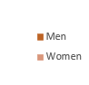The Pay quartile metrics look at the gender split of male and female employees, when we order the hourly rate of pay from highest to lowest and group into four equal quartiles.

In %

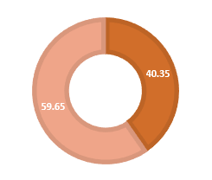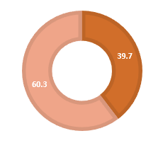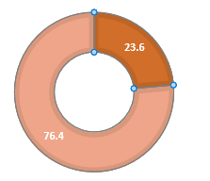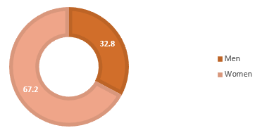

**Lower Quartile Gender Split**

**Lower Middle Quartile Gender Split**

**Upper Middle Quartile Gender Split**

**Upper Quartile Gender Split**

# **Why Macclesfield College has a ‘Gender Pay Gap’**

It is clear that a prime reason for the organisation-wide gender pay gap is ‘occupational

segregation’ and this requires further comment to understand its impact and the steps taken

by the College to close gaps identified. which is evidenced both horizontally and vertically

**60**

**Female Male**

**Female Male**

**Female Male**

**Female Male**

**Lower**

**Lower Middle**

**Upper Middle**

**Upper**

**20**

**41**

**13**

**42**

**23**

**35**

**34**

**23**

**50**

**Occupational Segregation Descriptor**

The distribution of people based upon demographic characteristics, in this case, gender.

**40**

**30**

**Horizontal Segregation Descriptor**

The difference in the amount of men and women present across particular types of College occupation.

**20**

**10**

**0**

**Vertical Segregation Descriptor**

Difference in the amount of men and women present across the levels of the College.

# **Horizontal segregation**

Regarding the types of occupational work undertaken the survey clearly evidenced that there exists across the College community a gender divide – irrespective of whether employees are from the Business Support, or Academic families.

* 1. **Business Support**

Due to the College’s operational needs and service provision on the ‘snap-shot date’ a significant number of part-time roles are available (i.e. job-share, term-time, flexible working contracts particularly in the lower quartiles.) Historically and at the time of reporting these roles have predominantly been occupied by female employees.

Business Support roles evidencing a higher representation of female staff are MIS & Exams, HR, Learner Experience and Student Services. Such administrative, advisory, management information roles are indicative of wider gender sector trends.

Conversely, male Business Support employees have a higher representation in the Construction and Estates fields.

* 1. **Academic Staff**

Aligned to the wider education sector, the College has experienced occasions where

there has been a difficulty to recruit to certain of its academic roles, this is attributable to ‘sector skill shortages within ever competing markets’ particularly in such areas as

Mechanical /Motor Vehicle Engineering/Construction. Such College roles have predominantly attracted a higher ratio of applications from male applicants; however, this pattern is reflective of the position nationally.

However, countering this pattern the College has had success in attracting females to these traditionally dominated roles, with the successful appointments and promotion of female staff to its management roles within these sector specialisms.

Conversely, academic roles such as Health & Social Care, Hair & Beauty and Childcare have a female bias, which again is reflective of national trends.

# **Vertical segregation**

Nationally, one of the main contributors to the gender pay gap is the higher ratio of male to female employees appointed to senior management roles. Such positions are primarily undertaken in a full-time capacity. Macclesfield College counters this trend with 100% of senior management roles undertaken by females.

There is a higher proportion of female employees employed in the lower support pay quartiles, and in both the business and academic families than men, amongst the reason for this may be:

Female staff are more likely than male staff to have had breaks from work that have affected their career progression, for example to raise children leading on occasion to a shorter job tenure.

Family commitments.

Carer responsibilities.

Preference to work part-time and/or term-time, (aligned with sector trends these are often in the two lower quartiles).

Macclesfield College’s Gender Pay Gap is therefore attributable to the roles which male and female employees undertake and the work patterns and salaries that these roles represent.

# **Employee Relations**

In the year up to 31st March 2024, there were no employment Grievances, or Disciplinaries related to any of the ‘protected characteristics.’

# **Promoting & Advancing Gender Diversity**

**Pay**

The college has transparent, structured Pay Scales that are not gender specific to ensure employee pay is fair and equal for all genders performing in the same roles. The college pay-scale that is not gender specific allows the college to pay males and females working in the same role equally. In addition, the college is working to reduce the gap by ensuring the pay-scales remain competitive and reflective of the workforce as well as paying the Real Living Wage.

**Recruitment**

Macclesfield College applies throughout its ‘recruitment cycle’ gender-neutral practices including:

Ensuring all advertising and recruitment media uses gender neutral language.

Utilisation of a diverse marketing media for College vacancies.

Provision of a wide range of flexible working opportunities as a means of attracting ‘new talent’ whilst supporting, developing and retaining ‘existing talent.’

A commitment to recruit and appoint staff on merit, ensuring the effective assessment of a prospective candidate’s skills, knowledge and aptitude for recruitment, promotion or a secondment opportunity.

**Family Friendly**

Commitment to the Equality Human Rights Commission ‘Working Forward’ Pledge which seeks to advance the Colleges existing commitment to diversity, inclusiveness and gender equality by making the College the best it can be for pregnant women and new parents.

In the coming year, the College is committed to developing a management toolkit to support the return of employees prior to, during and on return from maternity and other parental leave, this initiative will be supported by training resources which are complementary to the ‘Working Forward’ ideals.

**Continuous Professional Development/Training & Development**

Pro-actively promoting and delivering throughout the academic year a College programme of ‘Continuous Professional Development’ for all employees.

Advancing, Promoting and Fostering a culture of inclusiveness through all staff undertaking equality, diversity and inclusion training to inform their knowledge and understanding both in relation to the performance of their work responsibilities and their wider College responsibilities.

Creation of fair and open policies and processes that encourage and facilitate staff to develop and progress to achieve their true potential.

**Information & Advice - Career Pathways**

Ongoing employer engagement via Maxim the College’s ‘Employer Engagement Arm’ to promote and develop cross sector partnership working to promote the diversity of career pathways available for all.



Rachel Kay Principal & Chief Executive

Macclesfield College

# **Closing Statement**

Macclesfield College will continue to monitor its ‘Gender Pay Gap’ and will in accordance with its legal responsibilities publish a further report in 2026.

The College will in complying with the publication of its Gender Pay Gap Reporting maintain the data published for a period of three years in order to clearly evidence and report on the progress made.

The Gender Pay Gap Report was presented to the Corporation and Equality and Diversity Committee in April 2025.

The information presented in this Gender Pay Report has been created in accordance with and to comply with the ‘Equality Act 2010 (Gender Pay Gap Information) Regulations 2017, in relation to the ‘snap-shot date of 31 March 2024.